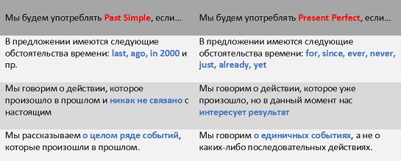

1. Complete the pairs of sentences. Use the Present Perfect in one sentence and the Past Simple in the other.

1.I (know)  _______ her for six years.

I (know) _______  him when I was at school.

2.He (live) _______  in Paris from 1997 to 2000.

He (live) _______  in New York since 2001.

3.Where's Pete? I (not see) _______  him for ages.

I (not see) _______  Pete last night.

4.I (not watch) _______  this video yet.

I (not watch) _______ a video at the weekend.

 2. Put the verbs in brackets in the Past Simple or in the Present Perfect.

1.  I ________ (never/ be) to the USA.

2.  He _______ (live) in this street all his life.

3.  His father ________ (come back) to London last Sunday.

4.  Yan __________ (write) a letter to Nick two days ago.

5.  He ________ (send) his letter yesterday.

6.  They  ________  (just/ buy) some postcards.

3.Choose the correct variant

1. We took /‘ve taken a taxi to town that morning.
2. We played /'ve played volleyball last night
3. I'm really hungry. I didn’t eat / haven’t eaten for ages.
4. They visited/ ‘ve visited Colorado last summer.

4.Correct the mistakes in these sentences.

1. We lived here since 1997.
2. I've been ill since two days.
3. How long do you know him?
4. Susie has seen a good film last night.
5. We've finished our homework just.
6. I've already wrote three letters.